**EXPERIMENT – 1**

**WAP IN PYTHON FOR FINDING THE GRADE BY GIVING THE INPUT OF FIVE SUBJECTS MARKS USING CONDITIONAL STATEMENTS**

**Aim: -** To perform python program for finding the grade by giving the input of five subjects marks using conditional statements.

**Algorithm: -**

Step 1 – Take input of student marks of all subjects.

Step 2 – Calculate percentage of student marks.

Step 3 – Create conditions of student grade based on percentage student achieve.

**Procedure: -**

sub_1 = int(input("Enter the marks of subject 1: "))

sub_2 = int(input("Enter the marks of subject 2: "))

sub_3 = int(input("Enter the marks of subject 3: "))

sub_4 = int(input("Enter the marks of subject 4: "))

sub_5 = int(input("Enter the marks of subject 5: "))

percentage = (sub_1+sub_2+sub_3+sub_4+sub_5)*100/500

print(f'Student Percentage: {percentage:.2f}%')

if percentage < 33:

print("Failed!")

elif percentage >= 33 and percentage <= 50:

print("E Grade!")

elif percentage > 50 and percentage <= 60:

print("D Grade!")

elif percentage > 60 and percentage <= 70:

print("C Grade!")

elif percentage > 70 and percentage <= 80:

print("B Grade!")

elif percentage > 80 and percentage <= 90:

print("A Grade!")

else:

print("A+ Grade")

**Input: -**

Enter the marks of subject 1: 45

Enter the marks of subject 2: 67

Enter the marks of subject 3: 89

Enter the marks of subject 4: 77

Enter the marks of subject 5: 60

**Output: -**

Student Percentage: 67.60%

C Grade!

**Result: -** Program executed successfully.

**EXPERIMENT – 2**

**WAP TO INPUT ANY NUMBER FROM USER AND CHECK IF IT IS A PRIME NUMBER OR NOT**

**Aim: -** To perform python program to input any number from user and check if it is a prime number or not.

**Algorithm:**

Step 1: - Take input number from user, which user want to check.

Step 2: - Use conditional statement and for loop to check the number is prime or not.

Step 3: - Print output after checking the number.

**Procedure:**

num = int(input('Enter the number: '))

if num > 1:

for i in range(2,int(num/2)+1):

if (num%i) == 0:

print(num,'is not a prime number')

break

else:

print(num,'is a prime number')

else:

print(num,'is not a prime number')

**Input:**

Enter the number: 7

**Output:**

7 is a prime number

**Result: -** Program executed successfully.

**EXPERIMENT – 3**

**WAP TO FIND SUM OF ELEMENT OF LIST RECURSIVELY USING PYTHON**

**Aim: -** To perform the program to find sum of element of list recursively using python.

**Algorithm:**

Step 1: - Define the function which sum the element in list recursively

Step 2: - Take five inputs from the user

Step 3: - Sum the elements, which we add in list

**Procedure:**

def recursive_sum(lst):

if not lst:

return 0

else:

return lst[0] + recursive_sum(lst[1:])

my_list = []

for i in range(1,6):

num = int(input(f'Enter the element {i} in list:'))

my_list.append(num)

result = recursive_sum(my_list)

print(f'Sum of elements present in list:{result}')

**Input:**

Enter the element 1 in list:23

Enter the element 2 in list:12

Enter the element 3 in list:32

Enter the element 4 in list:21

Enter the element 5 in list:10

**Output:**

Sum of elements present in list:98

**Result:** Program executed successfully.

**EXPERIMENT – 4**

**WAP TO FIND THE FACTORIAL OF THE GIVEN OR INPUT NUMBER**

**Aim: -** To perform the program to find the factorial of the input number given by user.

**Algorithm:**

Step 1: - Input a number form user

Step 2: - Assign initial factorial 1 and user conditional statements to find the factorial

Step 3: - Use ‘for’ loop to find the factorial

**Procedure:**

num = int(input('Enter the number:'))

factorial = 1

if num < 0:

print('Sorry, factorial does not exist for negative numbers')

elif num == 0:

print('The factorial of 0 is 1')

else:

for i in range(1,num+1):

factorial = factorial*i

print(f'The factorial of {num} is {factorial}')

**Input:**

Enter the number:5

**Output:**

The factorial of 5 is 120

**Result:** Program executed successfully.

**EXPERIMENT – 5**

**WAP TO FIND THE AVERAGE OF THE FIVE NUMBERS**

**Aim: -** To perform the program to find the average of the five numbers.

**Algorithm:**

Step 1: - Make an empty list variable

Step 2: - Use for loop to take input of five numbers and add numbers is empty list

Step 3: - Make a variable to store the average of numbers in the list and print the output

**Procedure:**

list_of_nums = []

for i in range(1,6):

nums = float(input(f'Enter the {i} number:'))

list_of_nums.append(nums)

avg = sum(list_of_nums)/len(list_of_nums)

print(f'Average of the five numbers taken from the user is {avg}')

**Input:**

Enter the 1 number:5

Enter the 2 number:4

Enter the 3 number:7

Enter the 4 number:9

Enter the 5 number:6

**Output:**

Average of the five numbers taken from the user is 6.2

**Result: -** Program executed successfully.

**EXPERIMENT – 6**

**WAP TO READ AN IMAGE USING OPENCV IN PYTHON**

**Aim: -** To perform the program to read an image using opencv in python.

**Algorithm:**

Step 1: - Import opencv python library.

Step 2: - Make variable to import the image with colors.

Step 3: - Read an image and close when user click “Close (x)” sign.

**Procedure:**

import cv2

img = cv2.imread("apple.jpg")

cv2.imshow("Apple Image",img)

cv2.waitKey()

cv2.destroyAllWindows()

**Input:**

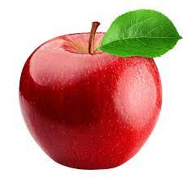

**Output:**

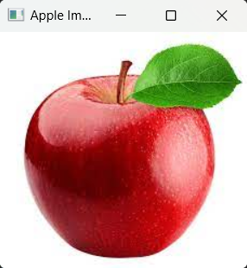

**Result: -** We successfully read an image.

**EXPERIMENT – 7**

**WAP TO DISPLAY THE IMAGE USING OPENCV IN PYTHON**

**Aim: -** To perform the program to display the image using opencv in python.

**Algorithm:**

Step 1: - Import opencv python library.

Step 2: - Make variable to import the image with colors.

Step 3: - Display an image using matplotlib imshow() function.

**Procedure:**

import cv2

import matplotlib.pyplot as plt

img = cv2.imread('car.jpg')

img = cv2.cvtColor(img,cv2.COLOR_BGR2RGB)

plt.imshow(img)

**Input:**

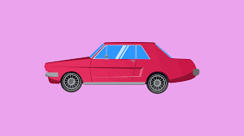

**Output:**

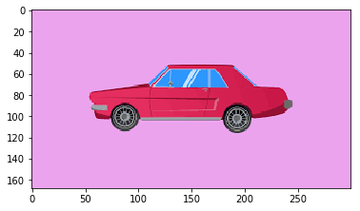

**Result: -** We successfully displayed an image.

**EXPERIMENT – 8**

**WAP TO MAKE A CIRCLE ON THE OBJECT OF IMAGE USING OPENCV IN PYTHON**

**Aim: -** To perform the program to make a circle on the object of image using opencv in python.

**Algorithm:**

Step 1: - Import opencv python library.

Step 2: - Make variable to import the image with colors.

Step 3: - Use opencv circle function to make a circle and display that image.

**Procedure:**

import cv2

import matplotlib.pyplot as plt

img = cv2.imread('car.png')

img = cv2.cvtColor(img,cv2.COLOR_BGR2RGB)

cv2.circle(img,center=(90,100),radius=(20),color=(0,0,255),thickness=2)

cv2.circle(img,center=(190,100),radius=(20),color=(0,0,255),thickness=2)

plt.imshow(img)

**Input:**



**Output:**

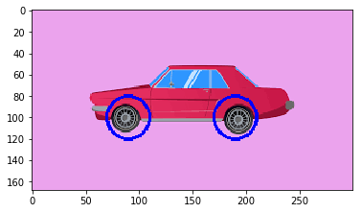

**Result: -** We successfully draw a circle on object of the image and displayed an image.

**EXPERIMENT – 9**

**WAP TO SPLITTING AND MERGING CHANNELS USING OPENCV IN PYTHON**

**Aim: -** To perform the program for splitting and merging channels using opencv in python.

**Algorithm: -**

Step 1: - Reading the BGR image using imread() function

Step 2: - Splitting the channels first to generate different single

Step 3: - Displaying Blue, Green and Red channel image.

Step 4: - Using cv2.merge() to merge Red, Green, Blue Channels.

Step 5: - Displaying Merged RGB image.

**Procedure: -**

import cv2

image = cv2.imread("car.png")

b, g, r = cv2.split(image)

cv2.imshow("Model Blue Image", b)

cv2.imshow("Model Green Image", g)

cv2.imshow("Model Red Image", r)

image_merge = cv2.merge([r, g, b])

cv2.imshow("RGB_Image", image_merge)

cv2.waitKey(0)

**Input: -**



**Output:**

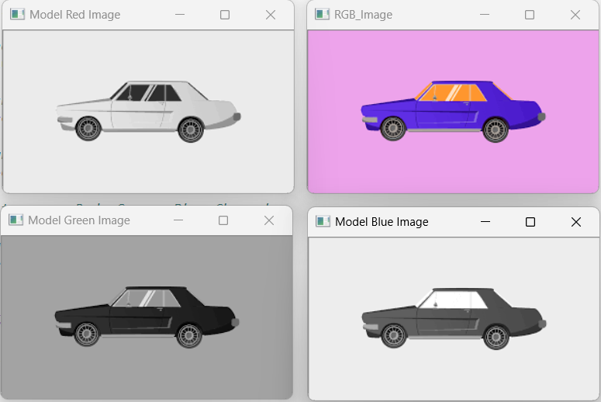

**Result: -** We successfully split and merge channels using opencv.

**EXPERIMENT – 10**

**WRITE A PYTHON CODE TO RESIZE AN IMAGE IN OPENCV USING PYTHON**

**Aim: -** To perform the program to resize an image in opencv using python.

**Algorithm:**

Step 1: - Import opencv python library.

Step 2: - Make variable to import the image with colors.

Step 3: - Use opencv resize() function to change the size of an image and display that resized image.

**Procedure:**

import cv2

import matplotlib.pyplot as plt

image = cv2.imread("car.png")

image = cv2.cvtColor(image,cv2.COLOR_BGR2RGB)

resize_img = cv2.resize(image,(400,400))

plt.imshow(resize_img)

**Input:**



**Output:**

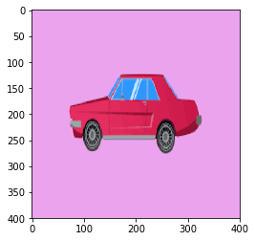

**Result: -** We successfully resize an image using opencv.

**EXPERIMENT – 11**

**WRITE A PROGRAM TO CONVERT IMAGE JPG TO PNG FORMAT USING OPENCV IN PYTHON**

**Aim: -** The aim of this program is to convert an image for jpg to png format using opencv python library.

**Algorithm:**

Step 1: Import relevant libraries, and load the image in JPG format.

Step 2: Save the image in PNG format.

Step 3: Check the conversion of image format by displaying that image, which is in PNG format.

**Procedure:**

import cv2

import matplotlib.pyplot as plt

# Read the image in JPG format

img = cv2.imread('C://Users/anu52/Downloads/ship.jpg')

# Save the image in PNG format

cv2.imwrite('C://Users/anu52/Downloads/cvt_ship_img.png',img)

# Check the conversion of image format

jpg_to_png_img = cv2.imread('C://Users/anu52/Downloads/cvt_ship_img.png')

plt.imshow(jpg_to_png_img)

**Input:**

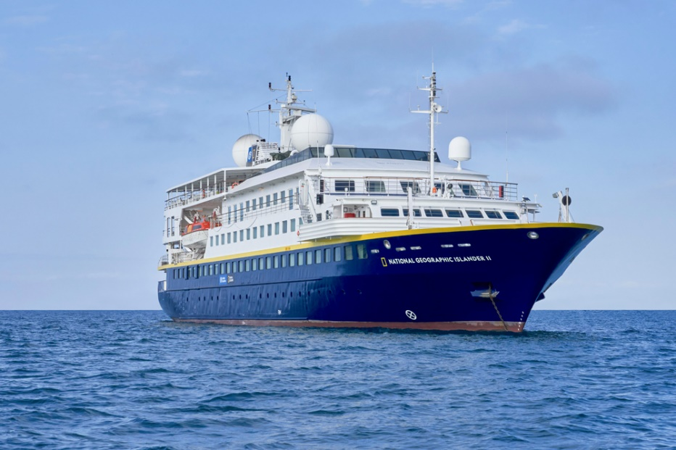

**Output:**

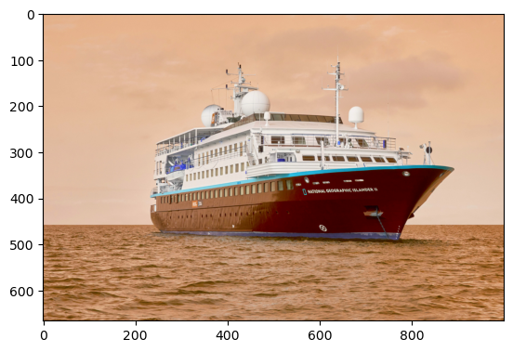

**Result: -** We successfully convert an image from jpg to png format.

**EXPERIMENT – 12**

**WRITE A PYTHON CODE TO CONVERT A COLORED IMAGE INTO A GRAYSCALE IMAGE USING OPENCV**

**Aim: -** The aim of this program is to convert a colored image into a grayscale image using opencv python library.

**Algorithm:**

Step 1: Import relevant libraries, and read the image in original colored image.

Step 2: Convert the colored image into grayscale image using opencv cvtColor() function.

Step 3: Display the grayscale image.

**Procedure:**

import cv2

img = cv2.imread('C://Users/anu52/Downloads/ship.jpg')

gray_img = cv2.cvtColor(img,cv2.COLOR_BGR2GRAY)

cv2.imshow('Gray',gray_img)

cv2.waitKey()

**Input:**

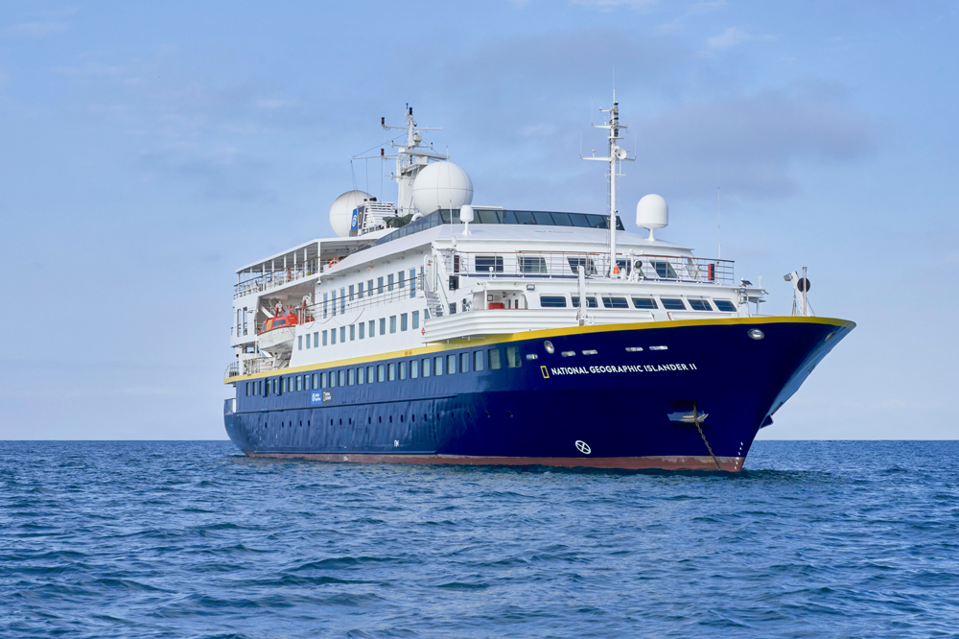

**Output:**

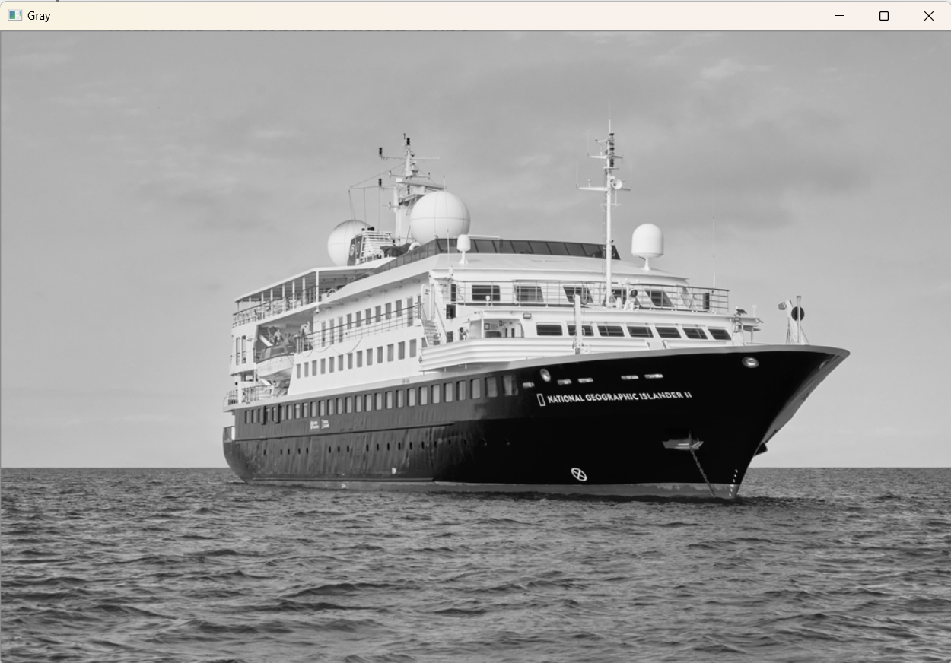

**Result: -** We successfully convert the image from colored to grayscale.

**EXPERIMENT – 13**

**WRITE A PROGRAM TO PLAY A VIDEO IN OPENCV USING PYTHON**

**Aim: -** The aim of this program is to play a video in opencv using python.

**Algorithm:**

Step 1: Create a VideoCapture object and read from the input file.

Step 2: Check if the video file opened successfully and Read until the video is completed.

Step 3: Display the resulting frame and when everything is done, release the video capture object.

**Procedure:**

import cv2

video_path = 'sample-5s.mp4'

cap = cv2.VideoCapture(video_path)

if not cap.isOpened():

print("Error: Could not open video.")

exit()

while cap.isOpened():

# Capture frame-by-frame

ret, frame = cap.read()

# If frame is read correctly ret is True

if ret:

cv2.imshow(‘Video’,frame)

if cv2.waitKey(25) & 0xFF == ord('q'):

break

else:

break

cap.release()

# Close all the frames

cv2.destroyAllWindows()

**Input:**

Video Path: C://Users/Downloads/sample-5s.mp4

**Output:**

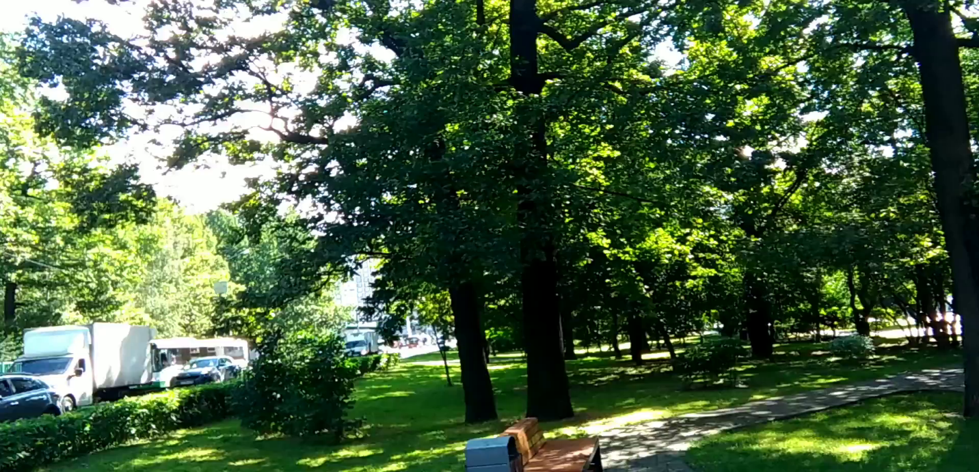

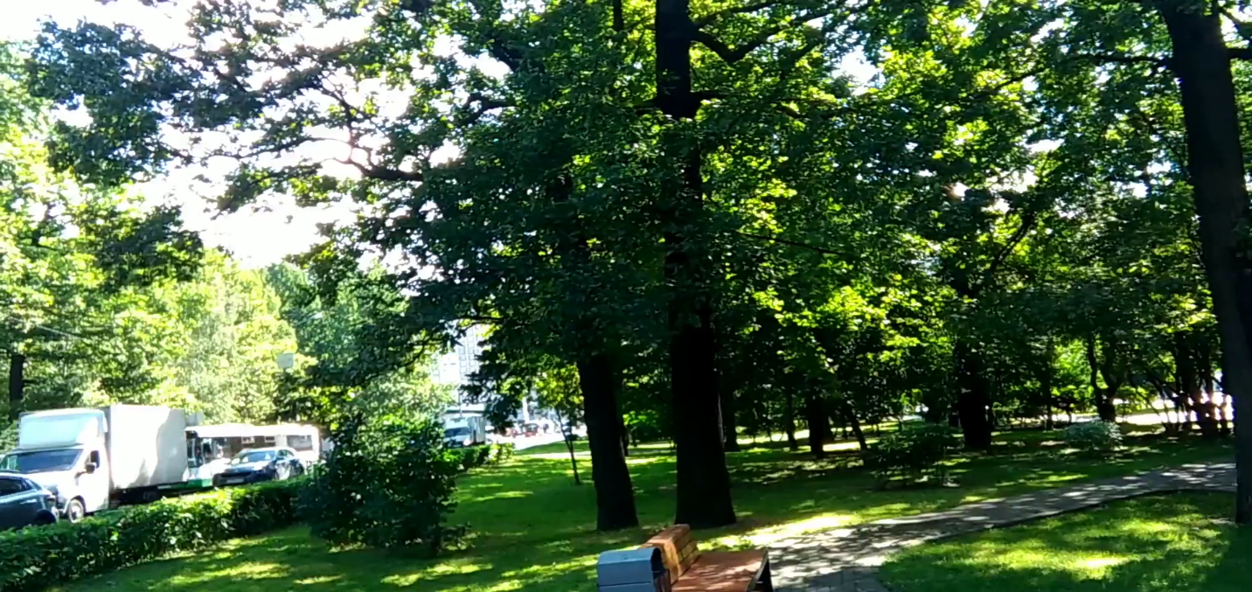

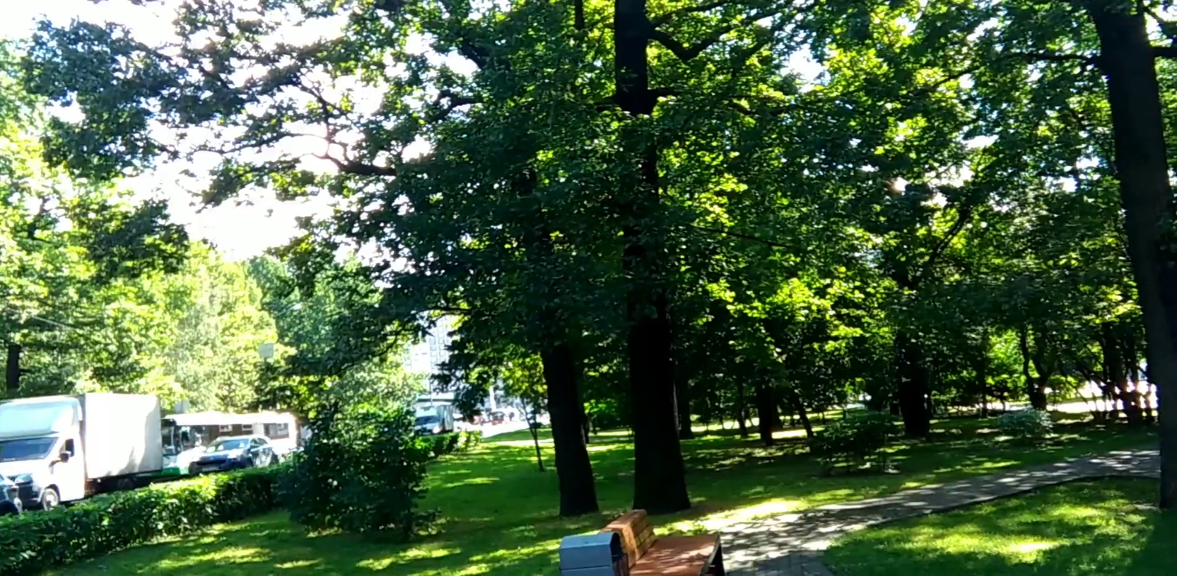

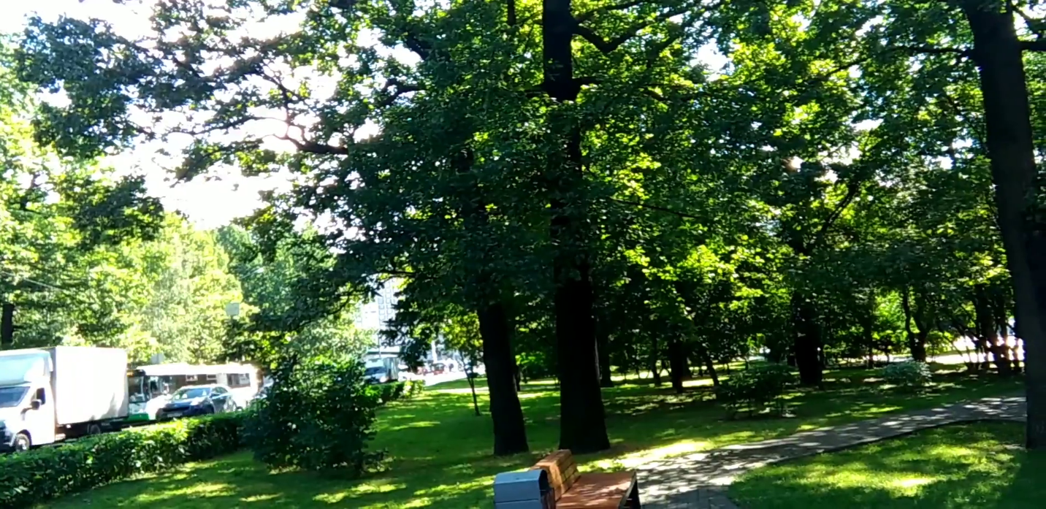

**Result: -** We successfully play the video and capture video frames using opencv python library.

**EXPERIMENT – 14**

**WRITE A PROGRAM TO EXTRACT AN IMAGE FROM VIDEO USING OPENCV IN PYTHON**

**Aim: -** The aim of this program is to extract an image from video using opencv python library.

**Algorithm:**

Step 1: Create a VideoCapture object and Check if the video has opened successfully.

Step 2: Create a directory to save the extracted images and Read and save each frame from the video.

Step 3: Save the frame as an image file and print the number of images we extracted from video.

**Procedure:**

import cv2

import os

video_path = 'sample.mp4'

cap = cv2.VideoCapture(video_path)

if not cap.isOpened():

print("Error: Could not open video.")

exit()

output_dir = 'Extracted_Images'

os.makedirs(output_dir, exist_ok=True)

frame_count = 0

while True:

ret, frame = cap.read()

if not ret:

break

frame_filename = os.path.join(output_dir, f"Image_{frame_count:04d}.jpg")

cv2.imwrite(frame_filename, frame)

frame_count += 1

# Release the VideoCapture object

cap.release()

print(f"{frame_count} images extracted and saved in '{output_dir}' directory.")

**Input:**

Video Path: C://Users/Downloads/sample.mp4

**Output:**

145 images extracted and saved in 'Extracted_Images' directory.

Image (One image from 145 images)

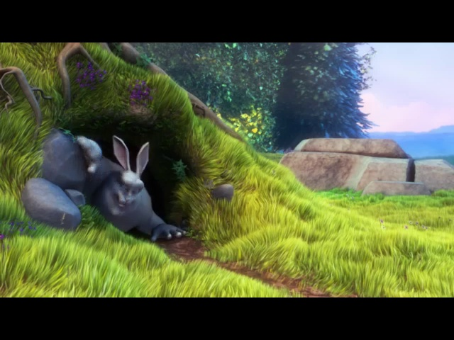

**Result: -** We successfully extracted images from the video using python opencv library.

**EXPERIMENT – 15**

**WRITE A PYTHON CODE USING OPENCV MODULE FOR ALL THE GEOMETRIC TRANSFORMATION OF IMAGE**

**Aim: -** The aim of this program is to perform the entire geometric transformation task on image.

**Algorithm:**

Step 1: Read input image.

Step 2: Apply all the geometric transformation on image.

Step 3: Display images.

**Procedure:**

1. **Scaling (Resizing) an Image:**

import cv2

import matplotlib.pyplot as plt

img = cv2.imread('ship.jpg')

img = cv2.cvtColor(img,cv2.COLOR_BGR2RGB)

resized_img = cv2.resize(img, (400, 300))

plt.imshow(resized_img)

**Input (For All Transformations):**



**Output:**

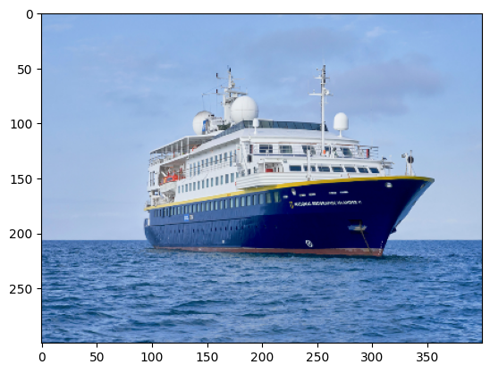

1. **Translation (Shifting) an Image:**

import cv2

import numpy as np

img = cv2.imread('ship.jpg')

rows, cols, channels = img.shape

M = np.float32([[1, 0, 100], [0, 1, 50]])

translation_img = cv2.warpAffine(img, M, (cols, rows))

plt.imshow(translation_img)

**Output:**

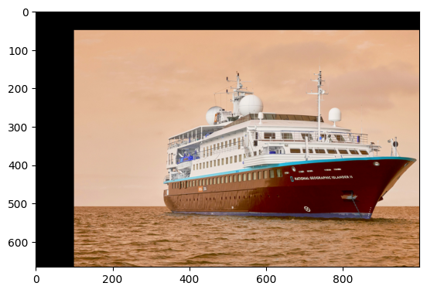

1. **Rotation of an Image:**

import cv2

img = cv2.imread('ship.jpg', cv2.IMREAD_GRAYSCALE)

rows, cols = img.shape

M = cv2.getRotationMatrix2D((cols/2, rows/2), 90, 1)

rotated_img = cv2.warpAffine(img, M, (cols, rows))

plt.imshow(rotated_img)

**Output:**

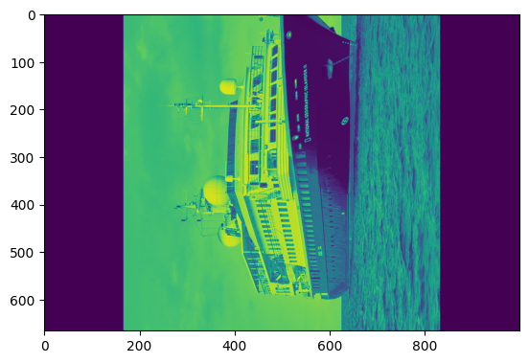

1. **Perspective Transformation:**

import cv2

import numpy as np

img = cv2.imread('ship.jpg')

pts1 = np.float32([[100, 100], [566, 100], [100, 900], [566, 900]])

width, height = 400, 600

pts2 = np.float32([[0, 0], [width, 0], [0, height], [width, height]])

M = cv2.getPerspectiveTransform(pts1, pts2)

transformed_img = cv2.warpPerspective(img, M, (width, height))

plt.imshow(transformed_img)

**Output:**

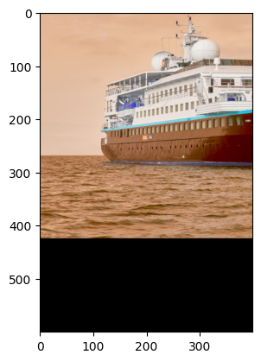

**Result: -** We successfully apply all the geometric transformation functions on an image using python opencv library.

**EXPERIMENT – 16**

**WRITE A PROGRAM FOR THREE COMPUTE HOMOGRAPHY TRANSFORMATION**

**Aim: -** The aim of this program we do three computer homography transformation.

**Algorithm:**

Step 1: Load the two images.

Step 2: Detect keypoint features in both images using a feature detection algorithm such as SIFT or ORB.

Step 3: Extract the descriptors for the keypoint features.

Step 4: Match the keypoint features between the two images using a feature matching algorithm such as Brute-Force Matching or FLANN (Fast Library for Approximate Nearest Neighbors) matching.

Step 5: Use the matched keypoint features to compute the homography transformation matrix using the RANSAC algorithm (Random Sample Consensus).

Step 6: Apply the homography transformation to warp one image onto the other.

**Procedure:**

import cv2

import numpy as np

img1 = cv2.imread(r”C:\Users\Admin\Desktop\CV\lion.jpg”)

img2 = cv2.imread(r”C:\Users\Admin\Desktop\CV\cub.jpg”)

sift = cv2.xfeatures2d.SIFT_create()

kp1, des1 = sift.detectAndCompute(img1, None)

kp2, des2 = sift.detectAndCompute(img2, None)

matcher = cv2.BFMatcher()

matches = matcher.match(des1, des2)

pts1 = np.float32([kp1[m.queryIdx].pt for m in matches]).reshape(-1, 1, 2)

pts2 = np.float32([kp2[m.trainIdx].pt for m in matches]).reshape(-1, 1, 2)

H, _ = cv2.findHomography(pts1, pts2, cv2.RANSAC, 5.0)

aligned_img = cv2.warpPerspective(img1, H, (img2.shape[1], img2.shape[0]))

cv2.imshow('Aligned Image', aligned_img)

cv2.waitKey(0)

cv2.destroyAllWindows()

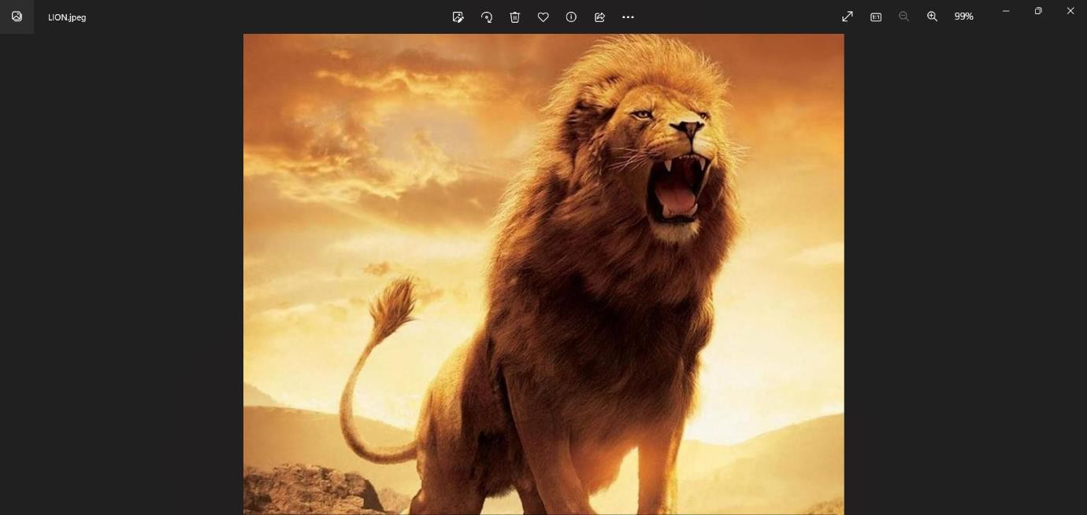**Input:**

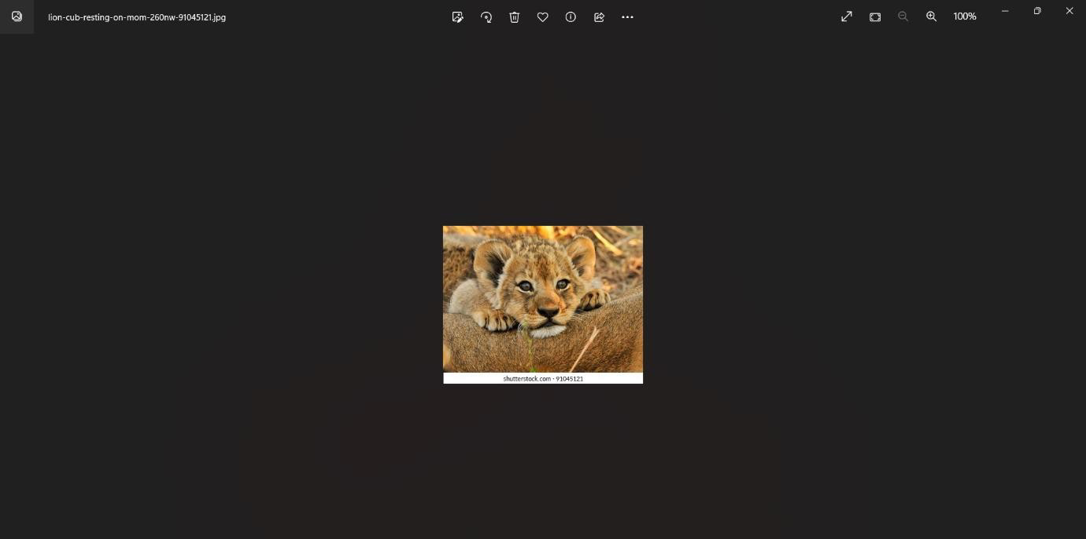

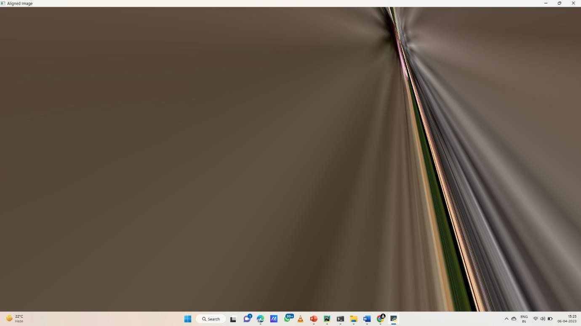**Output:**

**Result:** We successfully executed program for three-compute homography transformation.